**Java Microservices Based Unified Appointment Schedule Application**

The application is built on a microservices architecture, containerized with Docker, and designed to run on Linux based instances/servers.

**Backend Technologies:**

- Java 17: The core programming language for all microservices.

- Spring Boot: The framework used to build the three backend microservices.

- Spring Web: For creating REST APIs.

- Spring Data JPA: For communicating with the database.

- Spring Security: For securing backend services (though currently configured to permit all traffic).

- Maven: For managing project dependencies and building the applications.

**Frontend Technologies:**

- HTML5: The structure for all user-facing pages.

- CSS3: For styling the user interface.

- Vanilla JavaScript: For all client-side logic, including API calls and dynamic page updates.

**Database:**

- MySQL 8.0: A relational database used to store all application data. The data is logically separated into three schemas (`user_db`, `schedule_db`, `booking_db`), one for each service.

**Infrastructure & Deployment:**

- Docker: Used to containerize each of the three microservices, the MySQL database, and the Nginx web server.

- Docker Compose: Used to define, orchestrate, and run the multi-container application with a single command.

- Nginx: Acts as a reverse proxy and web server. It serves the static frontend files (HTML, CSS, JS) and forwards API requests to the appropriate backend microservice.

- AWS EC2: The cloud server where the entire Dockerized application is deployed and runs.

- Prometheus and Grafana: TO monitor the entire application and to trigger alerts by scrapping the metrics.

**2. Application & API Flow**

The application is split into three distinct microservices, each with its own responsibilities and database schema.

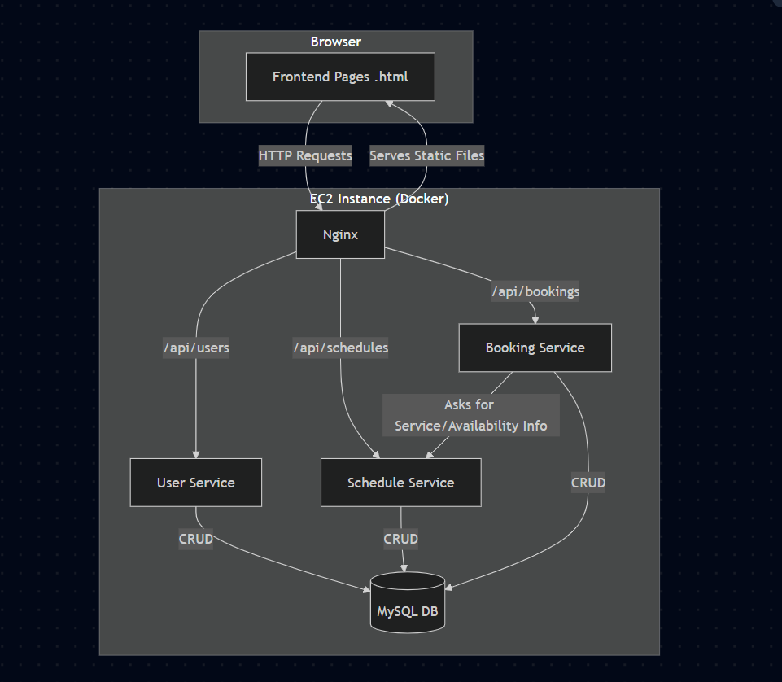

**Flow 1: Provider Onboarding:**

This flow describes how a service provider sets up their profile.

**1. Provider Registration (`index.html`)**

- Action: A provider fills out the registration form and submits.

- API Call: `POST /api/users/register`

- Service: `user-service`

- Logic: Hashes the provider's password and saves the new user record to the `users` table in `user_db`.

**2. Provider Login (`login.html`)**

- Action: A provider enters their credentials to log in.

- API Call: `POST /api/users/login`

- Service: `user-service`

- Logic: Verifies the credentials against the `users` table. On success, it returns the user's details. The frontend stores these details in the browser's Local Storage to manage the session.

**3. Provider Manages Services (`services.html`)**

- Action: The provider adds or edits the services they offer.

- API Call: `POST /api/schedules/services`

- Service: `schedule-service`

- Logic: Saves the service details (name, duration) to the `services` table in `schedule_db`.

**4. Provider Sets Availability (`availability.html`)**

- Action: The provider defines their weekly working hours.

- API Call: `POST /api/schedules/availability`

- Service: `schedule-service`

- Logic: Saves the availability rules (day of the week, start/end time) to the `availability` table in `schedule_db`.

**Flow 2: Client Booking an Appointment**

This flow describes how a client books an appointment with a provider.

**1. Client Views Booking Page (`booking.html`):**

- Action: The client navigates to the provider's public booking page.

- API Call: `GET /api/schedules/services/provider/{providerId}`

- Service: `schedule-service`

- Logic: The page fetches and displays all services offered by that provider.

**2. Client Selects Date to See Availability:**

- Action: The client chooses a service and a date.

- API Call: `GET /api/bookings/availability/{providerId}?serviceId=...&date=...`

- Service: `booking-service`

- Logic (Cross-Service Communication):

1. The booking-service` receives the request.

2. It first calls the `schedule-service` to get the duration of the selected service.

3. It then calls the `schedule-service` again to get the provider's general availability for that day of the week.

4. It queries its own `booking_db` to find any appointments that are already booked for that day.

5. Finally, it calculates the remaining open slots and returns them to the frontend.

**3. Client Confirms the Booking:**

- Action: The client selects an available time slot, fills in their name and email, and clicks "Confirm Appointment".

- API Call: `POST /api/bookings`

- Service: `booking-service`

- Logic:

1. The booking-service` receives the new appointment data.

2. It calls the `schedule-service` one last time to get the service duration.

3. It calculates the appointment's `endTime`.

4. It saves the complete appointment record to the `appointments` table in `booking_db`. (Note: The `userId` is currently hardcoded to `1` as a placeholder).

**Flow 3: Provider Viewing Appointments**

**1. Provider Navigates to Appointments Page (`appointments.html`)**

- Action: The provider clicks the "Go to Appointments" link on their dashboard.

- API Call: `GET /api/bookings/provider/{providerId}`

- Service: `booking-service`

- Logic: Fetches all appointments associated with that provider from the `appointments` table and returns them to the frontend to be displayed in a table.

**Flow 4: Monitoring**

1. Prometheus and Grafana are used to monitor the entire application. Node exporter is used to monitor the server metrics

**Deployment Model:**

This application is deployed in AWS EC2 instance (T2.medium) with 2 VCPU’s and 4 GB of RAM.

Logic is written in Java, HTML,CSS3 and JavaScript are used for webpages and MySQL is used to store data.

Maven is used to build the jar. Images are built using docker and pushed to GIT repository. These images are pulled from GIT into AWS EC2 instance. Nginx is also used as an image to act as an load balancer for the application.

Docker containers are started with these images with necessary security groups created to allow Inbound and Outbound traffic.

Security Groups:

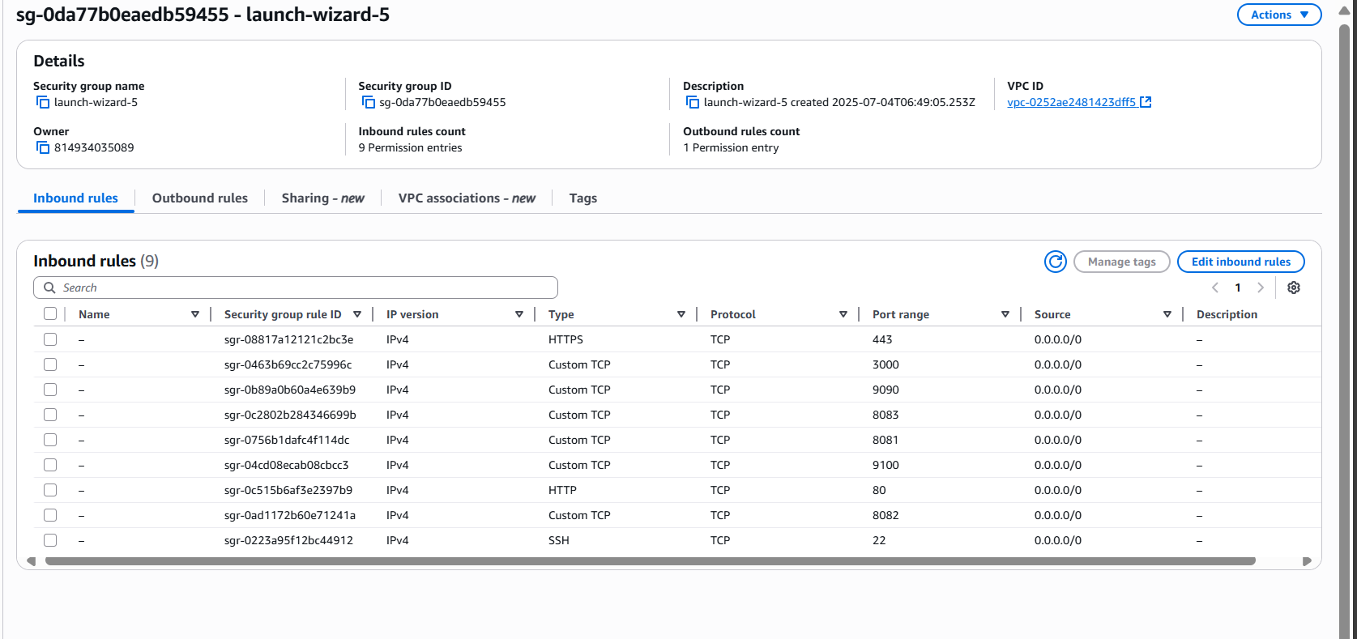

Journey:

1. There are 2 groups. 1. Provider and 2. Customer

The provider must register by accessing this URL )

After registering, they can login.

If the provider has already registered, they can directly login.

On the Dashboard, the provider has 4 options.

1 --> Manage services (Provider can add Service Name and Duration). All the services that are configured will be listed below.

2 -> Set Availability (Provider can schedule the timeslots available for booking day wise (Ex: 10:00 AM to 06:00 PM))

3 --> View Appointments (Provider can view appointments both Upcoming and Past)

4 --> Public Booking Page (This is for customers to book their appointments). http://13.235.79.75/booking.php?provider=3. This will be shared by the provider. Each provider has a different id. Based on that customers can log in and book their appointments

After booking, the page below will be displayed.